## Alternate Resources

* [GoogleTest documentation](http://google.github.io/googletest/primer.html)
* Prof. Koehler: [C++ Testing with Frameworks: Google & Catch v2.x](https://www.youtube.com/watch?v=s9fji4I_iOU)

## Prerequisites

* If Windows, work inside WSL: [CS 251 SP 24 - Windows](https://docs.google.com/document/d/11dAi4B1lJ14Y5KmYwnaBlgaHaVdrLultBy2O4vf0enc/edit#heading=h.ipy3e9uu5o32)
  + Have installed libgtest-dev (part of the above instructions)
* If Macos:
  + Have run xcode-select --install
  + Install brew by running /bin/bash -c "$(curl -fsSL <https://raw.githubusercontent.com/Homebrew/install/HEAD/install.sh>)"
  + Install googletest from brew: brew install googletest
  + In each project, you’ll need to tell VSCode C/C++ Extension where the googletest headers are:
    - F1, then enter “C/C++: Edit Configurations (UI)”
    - Scroll down to “Include path”, and add a line with /opt/homebrew/Cellar/googletest/1.14.0/include.
* If in zyBooks:
  + It’s already set up correctly, but then you have to deal with zyBooks.

## Anatomy of a Test

We use a gatherTokens test from Project 2:

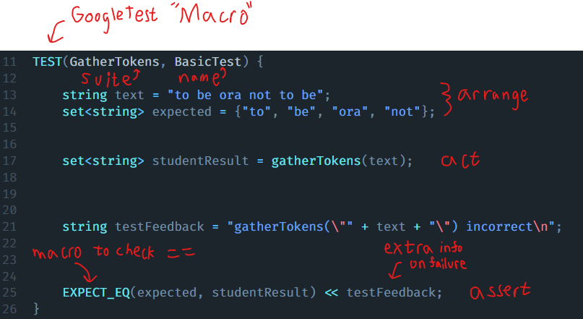

GoogleTests categorizes test using the (Suite, Name) combination. A “suite” is a collection of related tests. This combination must be unique.

A test is commonly in 3 parts:

* Arrange, where we set up the data to be used in the test
* Act, where we perform the “action being tested”
* Assert, where we verify that the Act was correct and output any information we need to.

Of particular note is the difference between EXPECT_EQ and ASSERT_EQ. When an ASSERT_ is false, the test stops immediately. However, EXPECT_ can fail, and the test will proceed, and provide more detailed feedback.

## Other Tips

* Running all tests can produce a lot of feedback that is hard to sort through. Instead, we can use [GoogleTest filters](http://google.github.io/googletest/advanced.html#running-a-subset-of-the-tests) to run only a few specific tests:
  + ./test --gtest_filter="randombag.isEmpty"
    - Runs only the test declared as TEST(randombag, isEmpty)
  + ./test --gtest_filter="randombag.*"
    - Runs tests declared as TEST(randombag, anyNameHere)

This document will be continuously updated as we find other pieces of GoogleTest that are useful for you to know.